Johannes Cassell
1636 - April 17, 1691

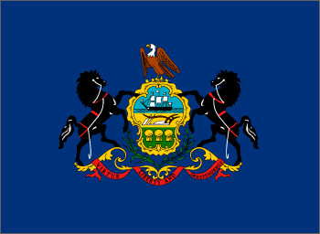
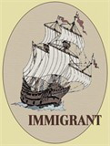

Johannes Cassel, born 1639 in Kriegsheim, Pfalz, Germany, and his wife, Mary, came to America in the ship " Jefries," and landed at Philadelphia, November 20, 1686, at the age of 47 years, from Kriegsheim, with his children. He was a weaver by trade and settled at Germantown, county of Philadelphia.

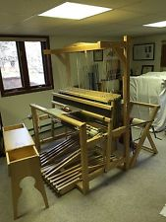
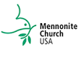

From A Biographical History of Lancaster County, Pennsylvania, we learn that: The first family of Cassels emigrated to this country, from Hesse Cassel, Germany, about the year 1680, and settled at Germantown, near Philadelphia, then a small town. At that place the Mennonites, of which the Cassel family were members, had a church and regular preaching. An incident occurred about this period going to show, in a very striking manner, the simplicity of the church at this time. A letter came from Europe to the Cassels that a large legacy was left them by the death of a relative, amounting to nearly a million dollars, and that they should send out and get the treasure. A church council was called and the matter freely discussed, when it was decided by a unanimous vote not to receive the money, as it would have a tendency to make them proud. Simplicity of manner, plainness of dress, frugality, honesty and economy were some of the characteristics of this people

Johannes Cassel, was, presumably, a son of Julius or Yelles Cassel of Kriegsheim, in the Palatinate. They left Europe for America, March 20, 1686, consequently a journey or voyage of seven months. He died April 17, 1691, aged 52 years; resided in Philadelphia. He also signed the application for a charter for the Borough of Germantown, and was one of the committee or members of first council of Germantown.
Source: Daniel Kolb Cassel "Cassel Family in America" https://archive.org/details/genealogicalhist00cass
Johannes may be buried here with his brothers Hubert and Yelles.

Mary Graeff
1643 - November 8, 1738

Mary was born 1643 in Kriegsheim, Pfalz, Germany, but came to America with her husband Johannes Cassel and their 9 children, aboard the ship " Jefries," which landed at Philadelphia on November 20, 1686. At the time, she was 43 years old.

Several sources say that Mary and Johannes married on December 20, 1686. But that can’t be as they have children starting in 1664.

Children: (all born in Germany)
- Arnold Cassell 1664-1720
- Peter Cassell 1666-
- Arnold Cassell 1664-1720
- Peter Cassell 1666-
- Elizabeth Cassell, our ancestor, 1670-1727
- Mary Cassel 1678-1728
- Sarah Cassell 1682- 1670-1727
- Mary Cassel 1678-1728
- Sarah Cassell 1682-

Little Sarah would have only been 4 yrs old when she made the arduous journey to the colonies while the oldest child, Arnold would have been a young man of 22.

Mary died on November 8, 1738 in Germantown, Philadelphia, Pennsylvania at the impressive age of 95. This is 47 years after her husband’s death and a decade after some of her children’s deaths!!

We don’t know any more than this about Mary.

